Immunization Policy Acknowledgment
FORM 3P
Archdiocese of Washington – Catholic Schools

ALL PARENTS OF STUDENTS ATTENDING ARCHDIOCESAN CATHOLIC SCHOOLS IN MARYLAND MUST READ THIS FORM, SIGN BELOW, AND RETURN IT TO YOUR CHILD’S SCHOOL WITH THE MARYLAND DEPARTMENT OF HEALTH AND MENTAL HYGIENE IMMUNIZATION CERTIFICATE (ADAPTED FOR USE BY ARCHDIOCESAN SCHOOLS).

To All Parents of Students in Archdiocesan Catholic Schools in Maryland

It is the policy of the Archdiocese of Washington that all students attending schools in the archdiocese must be fully immunized in accordance with the immunization requirements against contagious diseases published by the local department of health. If your child has a valid medical contraindication to being immunized, and such contraindication is documented by a physician, an exemption may be permitted for the length of time certified as necessary by the child’s physician.

Immunization in accordance with the Archdiocese of Washington’s policy is a condition for admission into all archdiocesan Catholic schools. To be admitted to attend classes, there must be two forms related to immunization on file at your child’s school by the first day of school, and they are:

- THIS FORM, completed and signed; and
- Maryland Department of Health and Mental Hygiene Immunization Certificate, (adapted for use by Archdiocese of Washington’s Catholic Schools in Maryland) signed by a medical provider and parents (Pages 2, 3, and 4).

Acknowledgment
To All Parents/Guardians: Please provide the following information and sign below to acknowledge that you understand and agree to this policy.
Child’s Name:
 |  |  |  | Last |  |  |  |  | First |  |  |  |  |  |  |  |  |  |  | M.I. |  | (Jr,. III)
School: |  |  |  |  |  |  |  | Sex: |  |  |  |  |  |  |  |  | Date of Birth:
 |  |  |  |  |  |  |  | Male Female mm/dd/yyyy
Parent/Guardian Name: |  |  |  |  |  |  |  |  |  |  | Home Phone: |  |  |  |  |  |  | ( ) -
Home Address:
 |  |  | Street Address |  |  |  |  |  |  |  |  |  |  |  |  |  |  |  | Suite #
 |  |  | City |  |  |  |  |  |  |  |  |  | State |  |  |  |  |  | ZIP Code
I have read and understand the Archdiocese of Washington’s Immunization policy listed above:
Parent/Guardian Signature: |  |  |  |  |  |  |  |  |  |  |  |  |  |  |  | Date:
 |  |  |  |  |  |  | Please Sign |  |  |  |  |  |  |  |  |  |  | mm/dd/yyyy

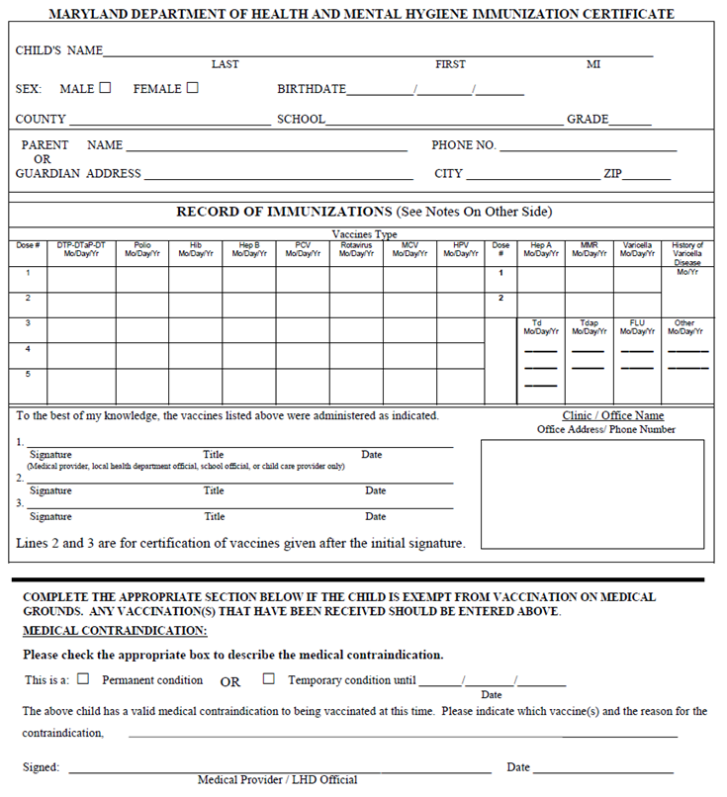

DHMH Form 896
Rev.02/14

